# Unit Testing in C++ with Test Explorer

# Grade: (50 points)

|  |  |  |
| --- | --- | --- |
| Ed Walker  Updated for Visual Studio Test Explorer on 26 Aug 2014 | Kent L. Jones  Updated for Google Test &  Other edits  30 January 2012,  11 February 2016 | Peter A. Tucker  Created for CPPUNIT on  31 August 2008 |

# Introduction

Nearly all professional developers write unit-level tests for their own code. It’s true at software companies in Spokane (e.g. NextIT, HachiSoft, etc.) and it’s also true at more well-known software companies such as Google, Microsoft, Real Networks, and Adobe. Those companies also have full-time testers who implement more complicated tests, such as system integration tests, performance tests, and stress tests. As a student in computer science, **you will make yourself more marketable to potential employers** if you **understand how to write your own unit tests**, and **how to use common unit-testing frameworks**.

Many companies have implemented their own unit-testing framework. At Microsoft (at least in the 90’s on the projects Pete worked on), unit tests are implemented in C++, and built and executed through a batch script. (These tests were called *check-in suites*, but they were very similar to unit tests.) A developer had to run all tests in the check-in suite before they could add their code to the main source tree. With the emergence of eXtreme Programming (XP) and Test-Driven Development (TDD), many companies have chosen to adopt a unit-testing framework.

The **JUnit** framework (<http://www.junit.org/>) was developed for programs written in the Java programming language. It consists of a set of libraries that make implementing and executing unit tests relatively easy. Because of the success of JUnit devlopers ported it to many other languages, including .NET (NUnit: <http://www.nunit.org/index.php>) and C++ (CPPUnit: <http://cppunit.sourceforge.net/cppunit-wiki>).

As most of our classes at Whitworth focus on C++, we encourage the use of test frameworks that support C++. In the past, we have used different C++ test frameworks such as **Boost Unit-Test** (<http://www.boost.org/doc/libs/1_56_0/libs/test/doc/html/utf.html>), and **Googletest** (<http://code.google.com/p/googletest/>)

For this class, we will use the C++ test framework integrated into **Visual Studio** called **Test Explorer**. You can be assured that all the concepts you learn using this framework will transfer to unit-testing on other test frameworks you use in the future.

# C++ Unit-Testing with Visual Studio Test Explorer

We will now explain how to use **Test Explorer** through an example. We’ll use a function described in the classic textbook on software testing by Glenford Myers. The function specification states:

**“Input three integers and return whether or not three lines of the given lengths can form a legal triangle.”**

**Designing the Tests for the Triangle Function**

Given this problem, we consider four **test cases** for our function (you could define more!). Each of the test cases assumes that **a**, **b**, and **c** are a specific triangle’s side lengths:

1. **a=3, b=3, c=3.** Function return: **true** (yes this can form a valid triangle)
2. **a=3, b=3, c=7.** Function return: **false** (no this cannot form a valid triangle)
3. **a=0, b=0, c=0.** Function return: **false** (no this cannot form a valid triangle)
4. **a=-1, b=-1, c=-1.** Function return: **false** (no this cannot form a valid triangle)

Certainly many more tests exist, including mutations of the above tests.

Note that in Test Driven Design (TDD), **we start to write the tests** **before we write the actual code that we are going to test!** Why is this? Because by writing a test, we are forced to think about the range of input values, input types, etc. that a function will accept. Writing the test first helps promote good software design.

**Creating a Function to Test**

Now that we have the tests designed, we need to write some code to test! In this case we are going to start by deliberately designing a function that is incorrect, (after all, we want our tests to tell us if a function does not work correctly for some test cases!). Below is the code we will work with in **section A** of this tutorial:

Header file **Triangle.h**:

#ifndef TRIANGLE_H_

#define TRIANGLE_H_

// This is a function prototype

bool isTriangle(int a, int b, int c);

#endif /*TRIANGLE_H_*/

CPP file **Triangle.cpp**:

#include "Triangle.h"

// NOTE: This function is deliberately incorrect.

bool isTriangle(int a, int b, int c) {

// A correct function would return true

// if a, b, c are valid sides for a triangle, i.e.

// if (a + b > c && a + c > b && b + c > a)

// return true;

// else

// return false;

return true; // PLEASE REMOVE THIS STATEMENT WHEN IMPLEMENTING

}

## Creating a Test Project

1. Start **Microsoft Visual Studio 2013**
2. Select **File | New Project…**
3. Create a new **Visual C++** **Win32 Console Application** project called **TestProject**
4. Browse to your CS273 folder on the Z: (//CS1/CS_Students) drive.
5. Select **Application Settings**
6. Under **Additional options:** make sure to
   1. **uncheck Precompiled header**
   2. **uncheck** **Security Development Lifecycle (SDL) checks**
   3. **check** **Empty project**.
7. Select **Finish**.

##### Create Triangle.h:

1. Right-click on **Header Files** and select **Add | New Item…**
2. Select **Header File (.h)** and then give the header file the name **Triangle.h**   
   then click on **Add**
3. Copy the code from the **Triangle.h** given above and paste it into the **Triangle.h** file.

##### Create Triangle.cpp:

1. Right-click on **Source Files** and select **Add | New Item…**
2. Select **C++ File (.cpp)** and then give the new source file the name **Triangle.cpp**
3. Copy the code from **Triangle.cpp** given above and paste it into the new **Triangle.cpp**

## Modifying the project to become a test project

##### Make this project a static library in order to export your isTriangle() function for other projects to use:

1. Right-click on **TestProject** project and select **Properties**
2. Select **Configuration Properties | General**
3. Select **Configuration Type** and change this to **Static Library (.lib)**
4. Click on **OK**

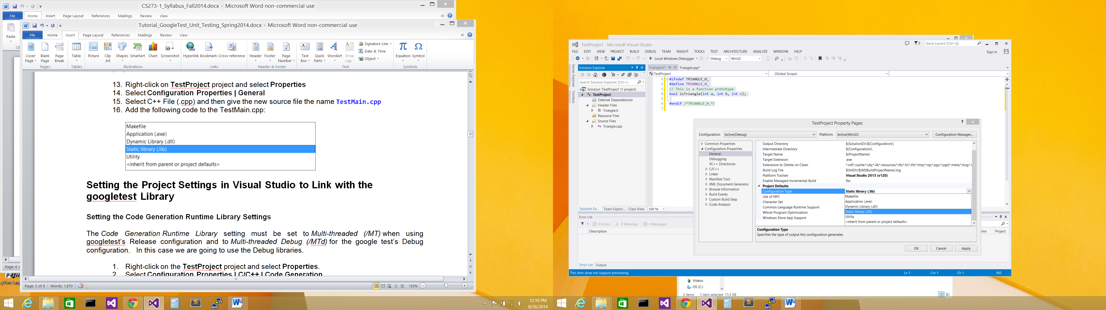

Select **Static Library (.lib)**

Create a Unit-Test project to test your function

1. Select your **TestProject Solution**
2. Right-click and select **Add | New Project ...**.

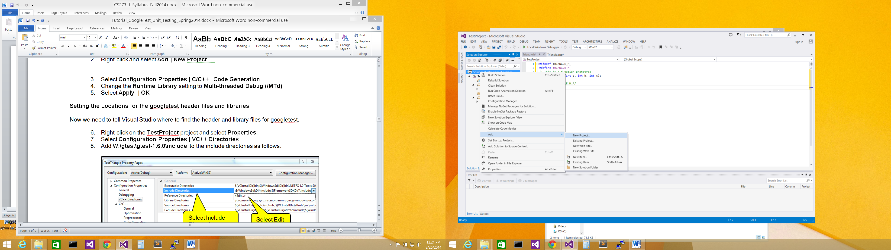

Select **Add** | **New Project …**

Select **TestProject Solution**

1. In the **Add New Project** dialog, select **Test | Native Unit Test Project**
2. Change the name of your project to **UnitTester**

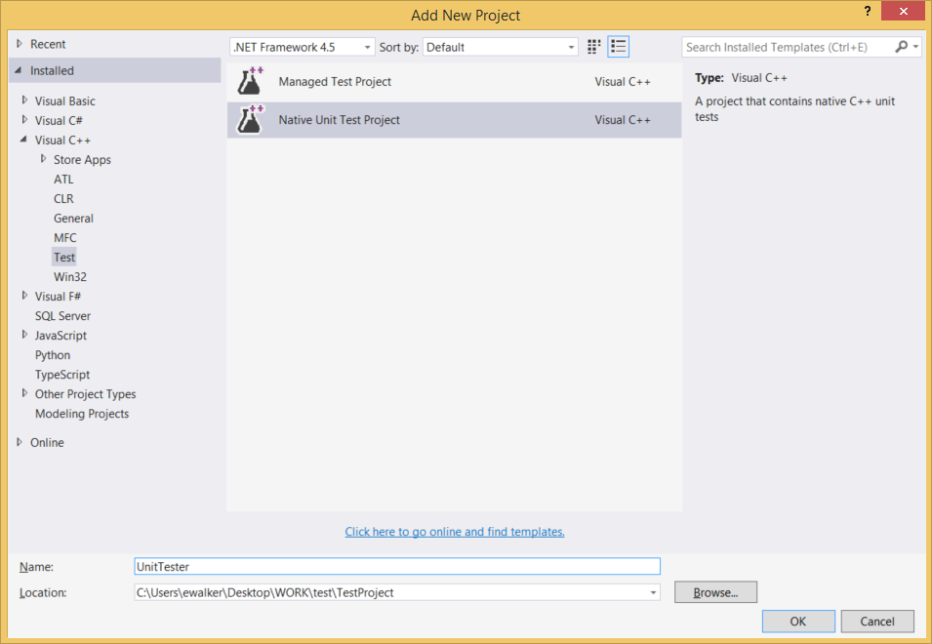

Select **Test**

Select **Native Unit Test Project**

Change name to **UnitTester**

1. Click **OK**
2. **Make sure you don’t miss a pop-up asking you if it’s ok to load a project from an “untrusted” site…**

##### Configure your Unit Test project to allow it to find your isTriangle() function:

1. Select your **UnitTester** project, right-click and select **Properties**.

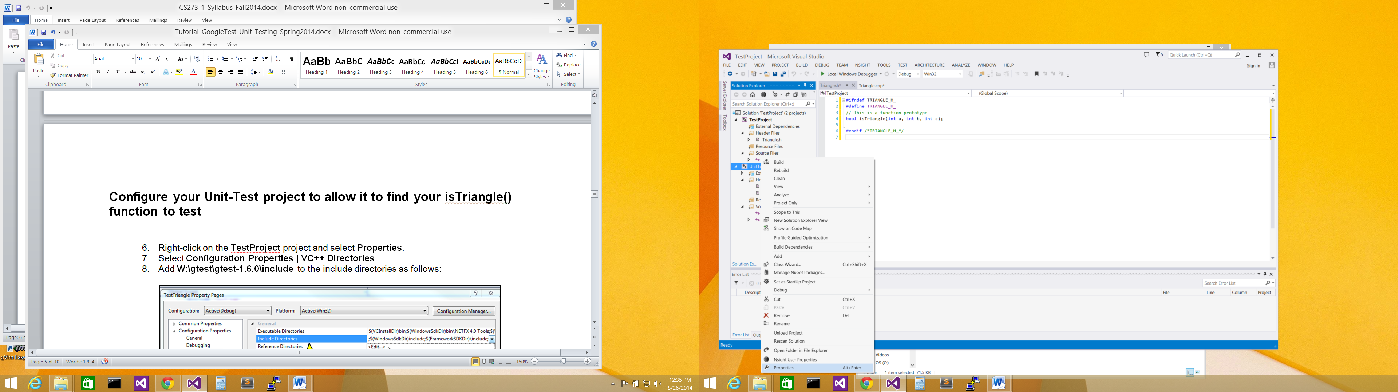

Select **UnitTester** project

Select **Properties**

1. Select **Configuration Properties | VC++ Directories**
2. Select **Include Directories** and click either **on the drop down box on the right side of the field. Select <Edit…> from the drop-down box.**

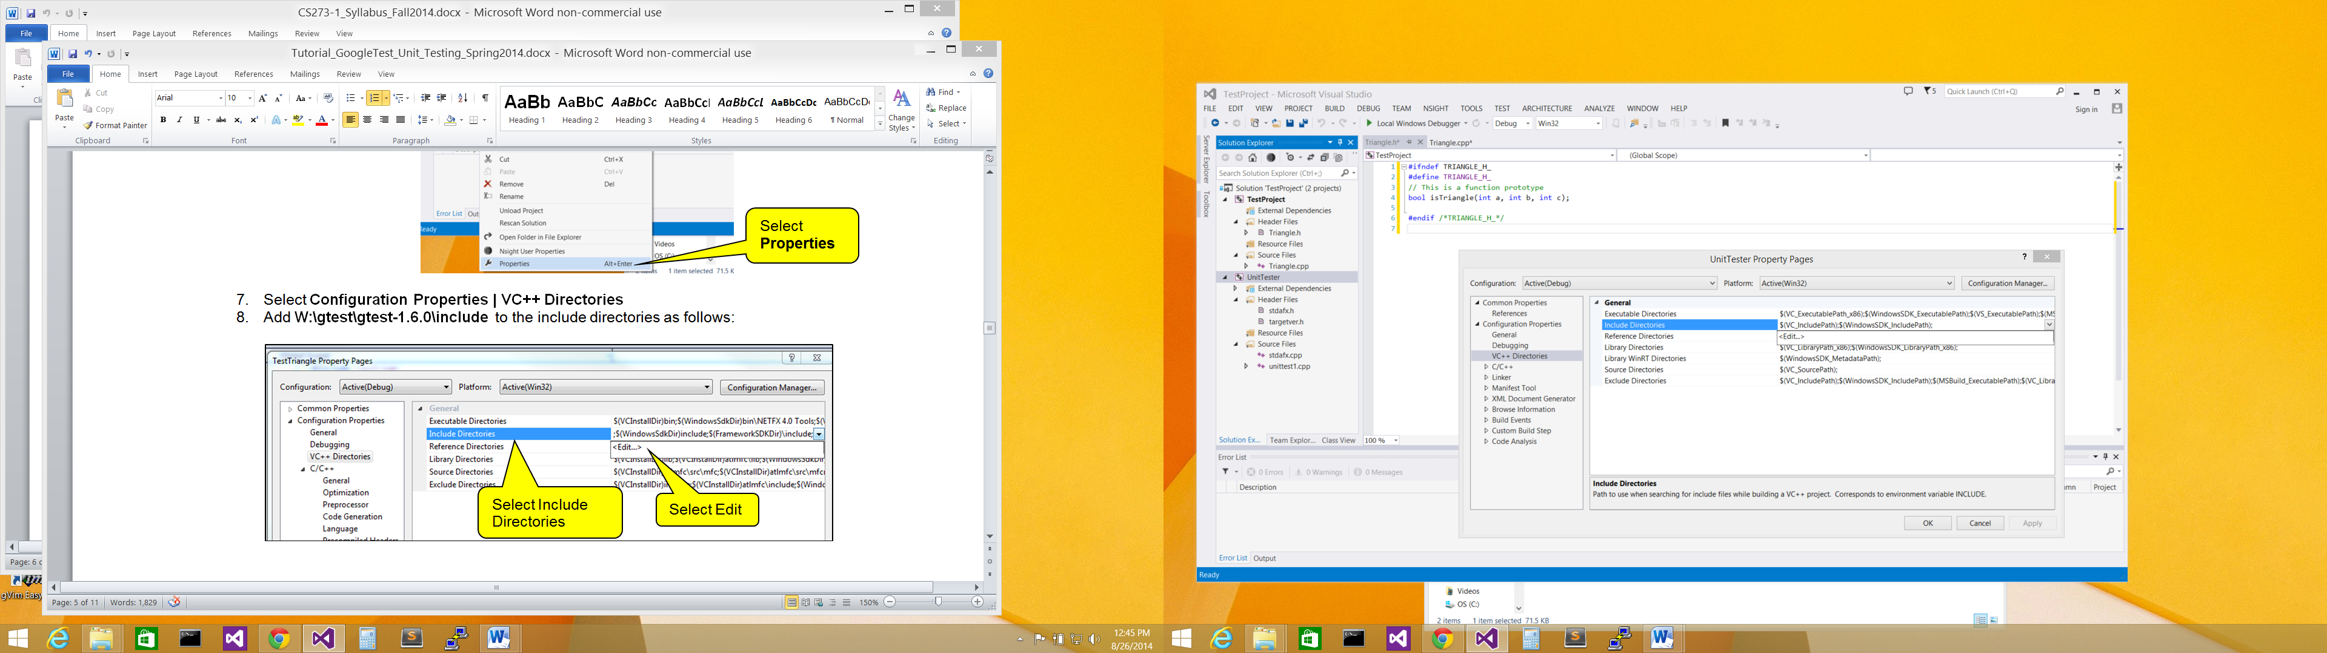

(c) Select **<Edit…>**

1. Select **Drop Down**
2. Select **Include Directories**
3. In the **Include Directories** dialog, double click in the top window and specify the path to the folder containing the **Triangle.h** file. The simplest way is to type in **$(SolutionDir)\TestProject\**

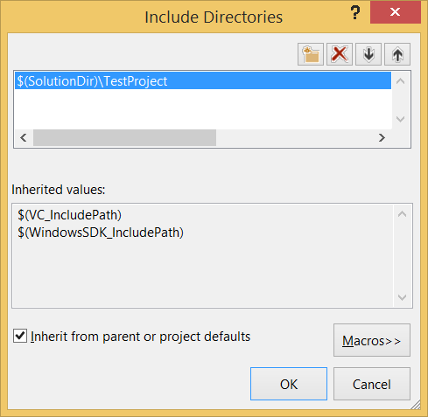

Click **OK**

Type **$(SolutionDir)\TestProject\**

1. Click **OK**
2. Back in the **UnitTester Property** dialog, under the **Common Properties** configuration, select **References | Add New References ….**

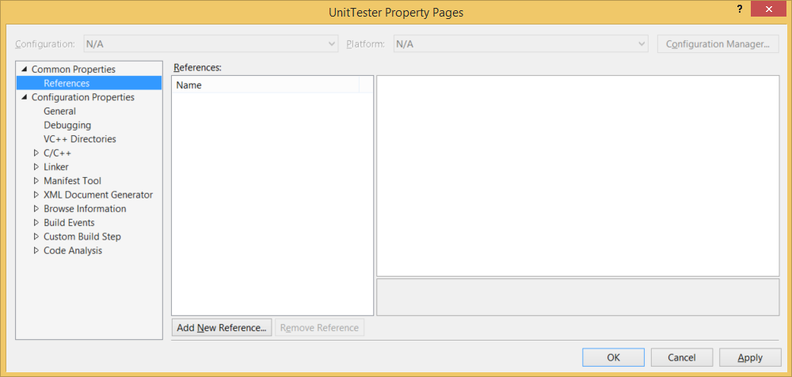

Select **Add New** **References …**

Select **References**

1. In the **Add Reference** dialog, check **TestProject**

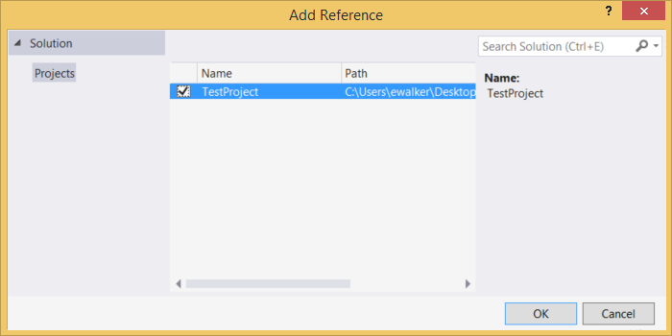

Check **TestProject**

1. Click **OK**
2. This will now take you back in the **UnitTester** **Property** dialog

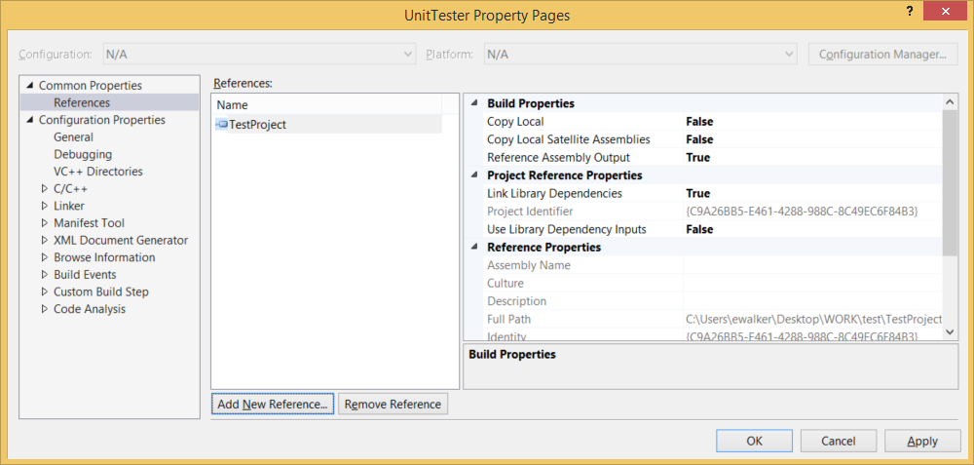

Click **OK**

1. Click **OK**

##### Add code to unit-test your isTriangle() function:

1. Select the **unittest1.cpp** file for editing.

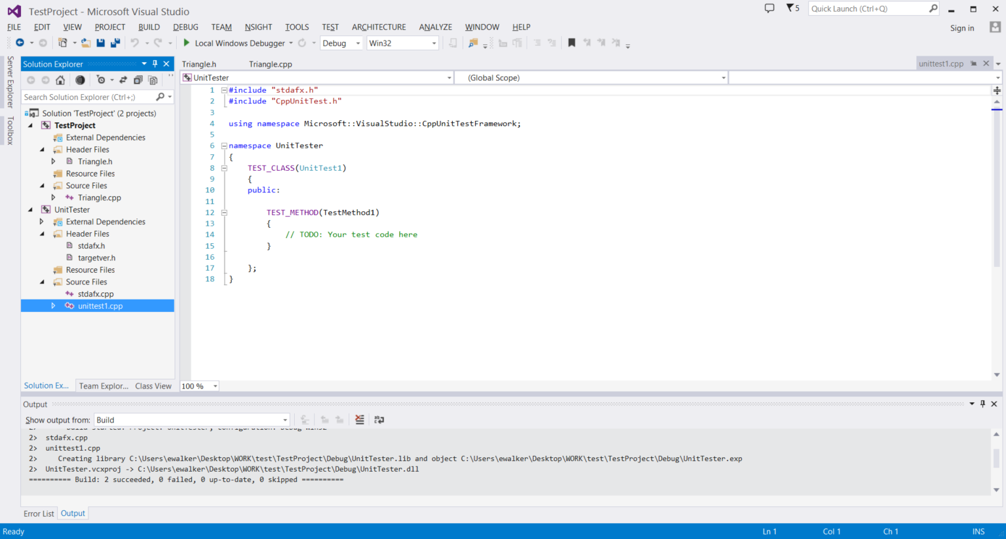

Select **unittest1.cpp**

1. We need to **replace** the **entire file** with the following code:

#include "stdafx.h"

#include "CppUnitTest.h"

#include "Triangle.h" // This must GO AFTER CppUnitTest.h!!!!

using namespace Microsoft::VisualStudio::CppUnitTestFramework;

namespace UnitTester

{

TEST_CLASS(TriangleTest) // This our test suite for testing isTriangle()

{

public:

TEST_METHOD(AllDifferent) // Test case 1: all sides different

{

// We are checking that isTriangle() should return true

Assert::AreEqual(isTriangle(3, 4, 5), true);

}

TEST_METHOD(TooLong) // Test case 2: one side is too long

{

// We are checking that isTriangle() should return false

Assert::AreEqual(isTriangle(3, 3, 7), false);

}

TEST_METHOD(Zeros) // Test case 3: all sides zero

{

// We are checking that isTriangle() should return false

Assert::AreEqual(isTriangle(0, 0, 0), false);

}

TEST_METHOD(Negatives) // Test case 4: all sides negative

{

// We are checking that isTriangle() should return false

Assert::AreEqual(isTriangle(-1, -1, -1), false);

}

};

}

In unit-testing, a **test-suite** is designed to contain a collection of related **test cases**. In this case, our test-suite is a class called **TriangleTest**. In this **test-suite**, we have implemented 4 **test cases**. Each test case reflects the test we wish to perform on **isTriangle()**, as detailed previously in this document.

##### Run the test-suite!

1. Select on the **Test** menu | **Run | All Tests**

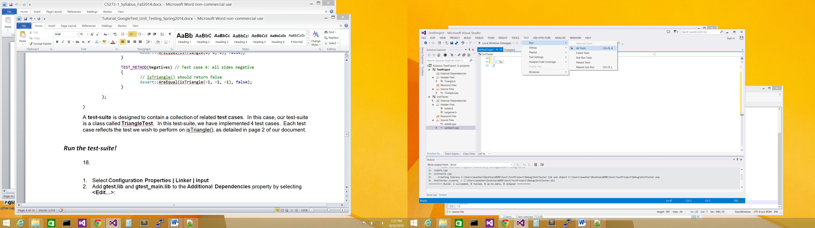

1. This will cause your **TestProject** to be automatically compiled, and your test-suite to run. If your program has an error, go back and check steps 7 – 10, make sure your TestProject was changed to be a static library!
2. After a little while, you should see the **Test Explorer** dialog appear.

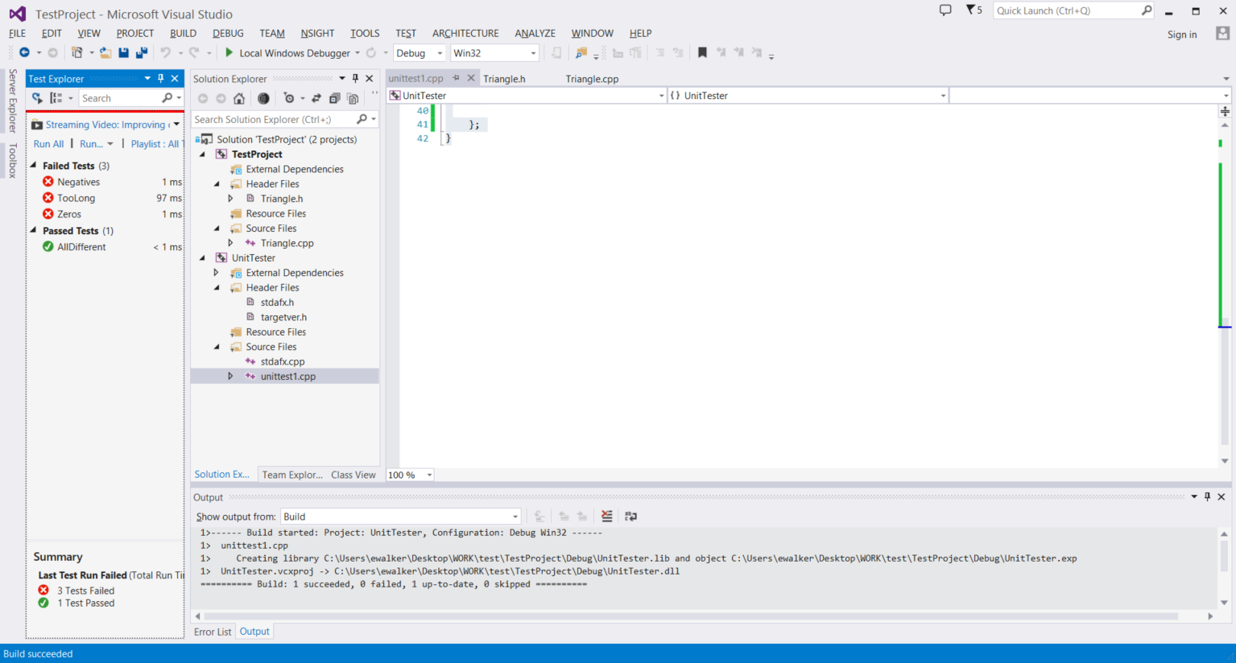

**Test Explorer** shows 3 test cases have failed, and 1 test case has passed!

## Tasks/Questions

1. (Question) Find the “Negatives” test case. Did it pass or fail? Why?
   1. It failed because when the numbers are added together they are less than the third number so it returned correctly.
2. (Task) Okay, now fix isTriangle() in Triangle.cpp remembering that the rule for a triangle with sides a, b and c is:

a + b > c **and** a + c > b **and** b + c > a

1. (Task) Rerun your test cases to make sure ALL test cases now succeed.
2. (Task) Let’s make add a Square to our **TestProject** project:

First, put your function prototype in the header file “Square.h”, and the function implementation in the CPP file “Square.cpp” in the **TestProject** project:

Header file **Square.h**:

#ifndef SQUARE_H_

#define SQUARE_H_

bool isSquare(int a, int b, int c, int d);

#endif /*SQUARE_H_*/

CPP file **Square.cpp**:

#include "Square.h"

bool isSquare(int a, int b, int c, int d) {

// A correct function would return true if a, b, c, d are valid sides for a square

return false;

}

**Do not implement the isSquare() function yet.**

1. (Task) Follow **Test Driven Design (TDD)** and **decide what** **test cases** you will need for **isSquare()** first! Come up with at least 3 **test cases**.

E.g. one test could be: If a=0, b=0, c=0, d=0 🡪 Expected result: false.

Come up with 2 additional tests – **one of these tests should return an expected result true**.

NOW Code your tests in **unittest1.cpp**, defining all of them in the **additional** **test suite** called “**SquareTest**”, (also included in the **UnitTester** **namespace**) add the following code for your first test case:

TEST_CLASS(SquareTest) // Test suite for testing isSquare()

{

TEST_METHOD(SquareZeros) // Test case 1: all sides are zero

{

Assert::AreEqual(isSquare(0, 0, 0, 0), false);

}

// Add your additional test cases here!

};

**NOTE! Remember to add #include "Square.h" at the top of unittest1.cpp**

There is no need to delete your “**TriangleTest”** test suite.

1. (Task) After coding the tests, implement the body of the function isSquare()so that all your tests passes.

**Call your instructor after you have completed your questions/tasks for credit.**

**Don’t worry if you can’t finish this tutorial in class. Complete this tutorial sometime in the next few days, and make sure your code is in your folder on CS1 for full credit.**

# Conclusion

Unit testing is an important practice in the software industry. Nearly all developers write their own unit tests. **Learn how to write unit tests now, and get in the habit of writing unit tests now. This will improve your solutions and make you more marketable to potential employers.**

There is more to Test Explorer than what we have shown you in this document!. Check out the online manual at**: http://msdn.microsoft.com/en-us/library/hh270865.aspx**

It’s a powerful testing suite with lots of functionality! Happy testing!